Assignment 3

Subject: Introduction to Computing
Cheating will get you zero marks!

Write a program in C++ to perform the following tasks according to user’s choice by using appropriate control structures.
Expected Output:
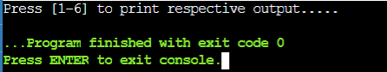
Sample output for choice 1
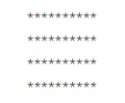
Sample output for choice 2
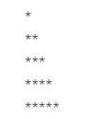
Sample output for choice 3
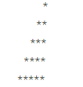
Sample output for choice 4
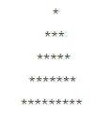
Sample output for choice 5
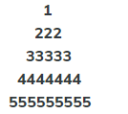
Sample output for choice 6
